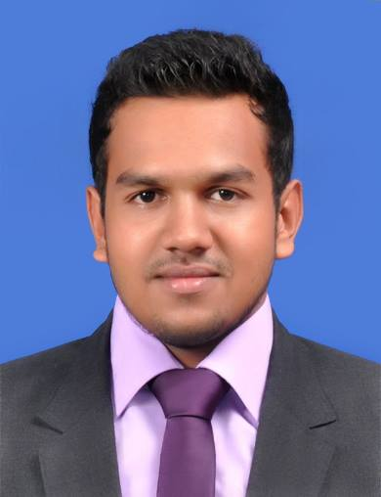 **CURRICULUM VITAE**

SHEHAN CHARINDRA FERNANDO

No :119,Katukurunda ,Moratuwa,Srri Lanka.

E-mail  **:** [shehan.cha@gmail.com](mailto:shehan.cha@gmail.com)

Mobile **:** (+94)756320212

Date Of Birth **:**15th December 1994

Nationality **:** Sri Lankan

**Objective:**

To obtain a position where I could share the expertise of my knowledge and also that will help me to enhance and make skills in a challenging environment to achieve the corporate goals and to improve customer satisfaction.

.

**PROFILE:**

* Finalizing Accounts by using Quick Books package.
* Maintaining accounting controls by following policies and procedures; complying with federal, state, and local financial legal requirements.
* Efficient in working with MS. Office ( MS. word, Excel, Power Point), Internet & E-mail operations.
* A quick learner, problem solver and able to work in challenging and diversified working environments.
* Good communication skill and quick understanding capacity and self-confident with a high sense of confidentiality.
* Very strong interpersonal and communication skills; work equally well one-on-one or in team setting.

**WORK EXPERIENCE:**

* Management Trainee at Sri Lanka Business Development Centre. ( In Finance section -December 2015 – To Date…)
* Assistant Accountant at LanCan Earth Movers.

(October 2013 - November 2015)

**Educational Proficiencies:**

* **Currently following a degree in Business Administration through at Edith Cown University- Perth Australia.**

Modules

- Accounting

- Management

- Business English

- Business communication and Analysis

* Successfully completed intensive English residential Course in Dioces of Rathnapura.
* Successfully completed Academic English Course in ACBT campus.

***G.C.E. (O/L) Examination 2010***

* Successfully completed G.C.E Ordinary Level Examination.

(1st sitting – December 2010 St.Sebastian’s College, Moratuwa, Sri Lanka)

***SUBJECT* *GRADE***

Sinhala C

English C

Accounting & C

Business Studies

Drama C

Mathematics C

Health & Physical C

Education

History C

Science S

Christianity S

***G.C.E (A/L) Examination 2013***

* Successfully completed G.C.E Advance Level Examination Commerce Stream.

(1st sitting – August 2013 in St.Sebastian’s College, Moratuwa, Sri Lanka)

Accounting C

Economics C

Business Studies C

**AREAS OF EXPERTISE:**

* Maintaining financial records for subsidiary companies by analyzing balance sheets and general ledger accounts.
* Correcting errors by posting adjusting journal entries.
* Finalizing Accounts by using Quick Books package.
* Final Accounts & Balance Sheet Reconciliation.
* Treasury Management and processing payments.
* Handling petty cash.

**Extra-curricular Activities:**

* Active Member in school IT society.
* Active member in school Commerce society.
* Active member of the school Cricket Team. ( Under 15-17)

**Non Related Referees:**

**Mr. K. A. Gihan Nadeeka**

Q. C. Manager

Export Processing Zone

Y. K. K. Lanka Pvt Ltd

F1, Seethawaka,

Awissawella, Sri Lanka.

Mobile : +94773624212

E-mail: [gihan.nadeeka@gmail.com](mailto:gihan.nadeeka@gmail.com)

**M.S.C.Fernando Date: 10/ 02/2016**